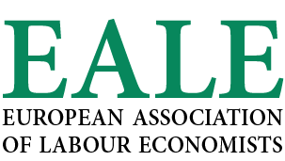

EALE NEWSLETTER JULY 2022

MESSAGE FROM PRESIDENT
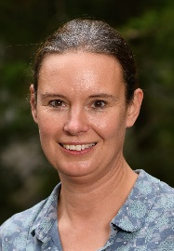
After two years of Pandemic and two on-line conferences, I am really looking forward to welcoming you in person at the 34th EALE conference on 8-10 September!
The department of Economics, Marco Fanno, of the University of Padova is excited to be your host for this year’s conference as they will do their best to make this conference to a success. The Department of Economics and Management of Padova is one of the youngest Departments in an ancient European university, which dates back to 1222. It offers one of the best Economics and Management degrees in Italy according to Censis, a leading Italian think tank and it is also a Department of Excellence endowed with special funds by the Ministry of Education.
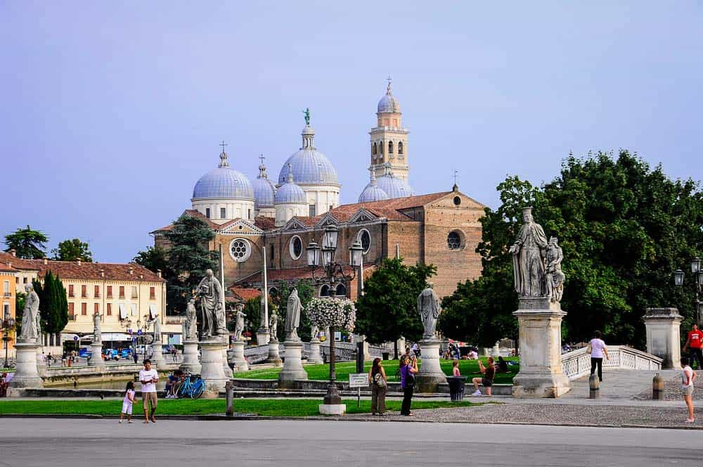
The local organizing committee has been working very hard to continue scientific exchange. This year’s conference will offer a varied programme with different types of scientific sessions and events:
- KEYNOTES:
Paolo Pinotti and Andrea Weber will be giving the keynote lectures.
- INVITED FLASH-TALK SESSIONS on three specific themes:
(1) Economics of Crime (organized by Katrine Løken), (2) Automation, Robots and the Future of Labour (organized by Lorenzo Rocco and Marco Bertoni) and (3) Immigration (organized by Albrecht Glitz).
- Many parallel sessions and two poster sessions.
- JOB MARKET: As usual, we will be promoting the job market candidates of this coming academic year. They will be presenting in dedicated job market sessions and will participate to a “Meet & Greet” breakfast (we strongly encourage you to participate)
The full programme is now available HERE.
I am very much looking forward to meet you all again in person in Padova in September!
Michèle Belot
EALE President

EALE JOB MARKET TOUR
We are proud to report on the first EALE Job Market Tour that took place in the week of 15th May. The tour started off at Uppsala University on 16th May. Three excellent young labour economists, Simon ter Meulen from the University of Amsterdam, Elisa Facchetti from Queen Mary University and Fabrizio Colella from University of Lausanne presented their work and interacted with local faculty and PhD students before travelling to Rotterdam and then on to Paris School of Economics for the final stop. The tour was highly appreciated by all involved and we hope that it will become an established institution in the years to come.

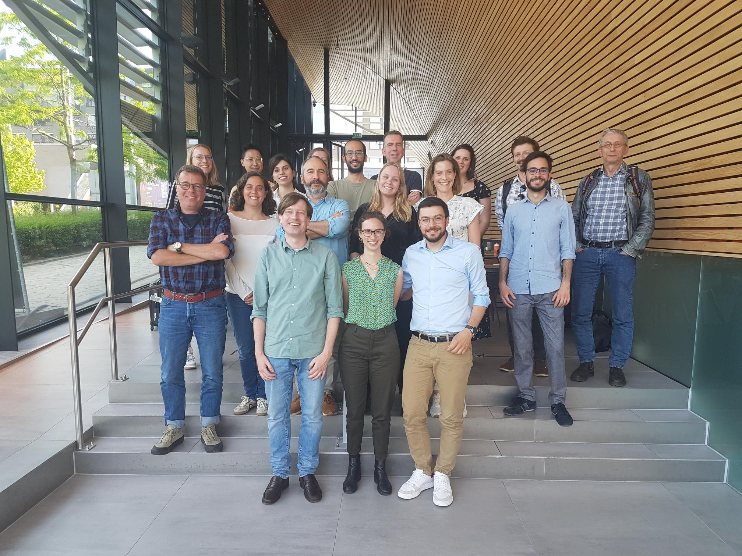

The EALE tour is meant to support the career of young economists in the field of Labour Economics. A group of the three promising doctoral students in the field of Labor Economics in Europe is selected by the EALE Job Market Committee and has the opportunity to present their work in three economics departments or institutes in Europe.
The next EALE Tour will take place from 17 to 22 April 2023 at University of Amsterdam, IAB (Nurnberg) and University of Milan. The selection of the three Job Market Candidates for the EALE 2023 tour will be announced after the Padova conference.

ANNOUNCEMENT EALE CONFERENCE 2023

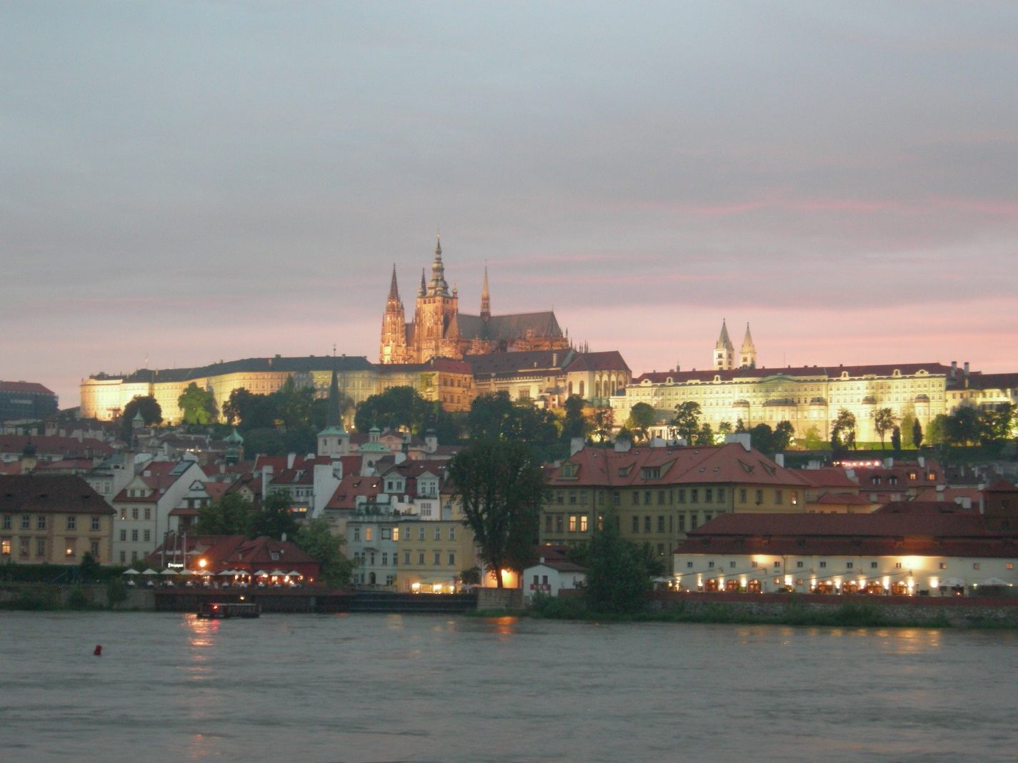

The EALE 2023 conference will take place in Prague on September 21-23. It will be organized by a team of Economists from CERGE-EI, Faculty of Social Sciences (Charles University), and Prague School of Economics: Mariola Pytlikova, Barbara Pertold-Gebicka, Klara Kaliskova, and Paolo Zacchia. We still have not chosen the final conference venue. We have offers from the Faculty of Law at Charles University and from Prague School of Economics. Both campuses are well-suited for such a large conference. Prague is a perfect conference city. It is easily accessible from all European countries with plane and/or train connections. City center is reachable from Prague airport within 30 minutes. Prague offers many tourist attractions within walking distance from the city centre: Prague castle, Charles Bridge, and the astronomic clock at the Old Town Square are the best known landmarks, but one can discover so much more by just strolling around the narrow streets of the Old Town and the Lesser Side.

INFORMATION OTHER CONFERENCES AND NETWORKS

The XIV European Conference of the Rodolfo De Benedetti Foundation (fRDB) will be held on Monday September 12 in Chioggia, located 20km away from Padova. The conference title is "Monopsony, Wages and Working Conditions. Keynote speaker will be Professor Alan Manning (LSE). If you plan to attend the meeting, please send an email to roberta.marcaletti@unibocconi.it - she will arrange a transfer from/to Padua and give you suggestions for accommodation.

AASLE (Asian and Australasian Society of Labour Economics) 2022 Conference
Date: 8-10 December 2022
Location: The University of Tokyo, Japan
Submission deadline: 17 July 2022

Research Network of Women in Data Science (WIND)
Chiara Binelli (University of Bologna) has started this new network initiative to connect women using Data Science and Machine Learning in the Social Sciences. The network brings together women working on Data Science to inform decision making and answer relevant policy questions in the Social Sciences. The network provides a venue to promote and facilitate cooperation and offers an organizational basis for research, teaching, and policy-oriented dissemination activities.
Google form to express interest: https://forms.gle/4vFXVjPrV75vuqcn8
For any question, feedback, and suggestion, you can contact Chiara Binelli, Associate Professor of Economics, University of Bologna.

We welcome our members’ contribution to the EALE Newsletter
The EALE Newsletter provides information on the association's activities, within the association's framework. All members are kindly invited to use the EALE Newsletter to make announcements of events in the field of labour economics. Please send all contributions to the EALE secretariat.
Deadline for copy for our next issue is 15th November 2022.

EALE | European Association of Labour Economists
Maastricht University | School of Business and Economics
Research Centre for Education and the Labour Market
P.O. Box 616, NL-6200 MD Maastricht
+31 6 14324582
www.eale.nl | eale-sbe@maastrichtuniversity.nl

